
Volume x Edition x (xxxx) Pages x-xx
Obsession Journal: Early Childhood Education Journal
ISSN: 2549-8959 (Online) 2356-1327 (Print)

TEACHERS HAVE PROBLEMS TEACHING EARLY CHILDREN DURING THE COVID-19 PANDEMIC

Nuryati ¹ , Yonia Ilma Insyira ² , Nisa Nuranisa ³ , Uyu Muawanah ⁴
Postgraduate UNTIRTA, STKIP Site Banten, Indonesia ^{1.3}
PIAUD Al-Khairiyah University Cilegon City, Indonesia ²
Postgraduate UNTIRTA, Indonesia ³
UIN SMH Banten, Indonesia ⁴

*7782210004@untirta.ac.id, nuryatimamah70@gmail.com ¹
ilmayonia@gmail.com ²
7782210023@untirta.ac.id ³
Uyu.muawanah@uinbanten.ac.id ⁴

Abstract: Study this aim for know teacher problems in teaching PAUD during the Covid-19 pandemic in the District Attack, and for know effort made _ in overcome Thing that. The subject study is a PAUD teacher in the district Attack consisting of 126 respondents from 108 PAUD institutions in the district Attack. Method research used _ is descriptive quantitative with survey technique, researcher To do Interview with spread questionnaire online to _ respondents. The evaluation questionnaire uses the Guttman scale. Research results show that 65% of the total PAUD ( Similar Education Units ) in the district attack show many problems faced by PAUD teachers when teach especially during the pandemic , so conducted a survey on all PAUD teachers in Serang . The later district from survey results show same result and opinion _ that is demands from parents _ for implemented system offline learning or stare face; so that learning more effective and optimal.
Keywords: _ problem, Teaching, early childhood teacher.
study this aim for know teacher problems in teaching PAUD during the Covid-19 pandemic in the District Attack, and for know effort made _ in overcome Thing that. The subject study is a PAUD teacher in the district Attack consisting of 126 respondents from 108 PAUD institutions in the district Attack. Method research used _ is descriptive quantitative with survey technique , researcher To do Interview with spread questionnaire online to _ respondents. evaluation questionnaire uses the Guttman scale. Research results show that 65% of the total PAUD ( Similar Education Units ) in the district attack show many problems faced by PAUD teachers when teaching, especially during the pandemic, so that done supervision for PAUD teachers throughout the district Attack later _ from results survey shows the same result and opinion _ that is as from parents _ for done system offline learning or stare face; so that learning more effective and optimal.
Keywords: _ problem; Teaching; early childhood teacher.

Copyright (c) 2022, Nuryati , et al
Suitable authors: Nuryati
Email Address : nuryatimamah70 @gmail.com ( UNTIRTA, STKIP Banten Site )
Received the day of the month of the year, Received the day of the month of the year, Published the day of the month of the year

PRELIMINARY
At the beginning of 2020, the world was shocked by information about the Covid 19 pandemic that attacked the country of China, especially the Wuhan area, where the Coronavirus was first detected. All leaders of their respective countries have issued policies to suppress the Covid 19 pandemic so that it does not enter their countries, including Indonesia. Apparently, the spread of the Covid-19 outbreak was very fast. This happens because the coronavirus is invisible to the naked eye. the effect felt by the sufferer is not too significant. The Indonesian government swiftly closed all entrances without exception. When it was done, it turned out that there were already two Indonesian citizens who had contracted the virus.
This did not break the government's spirit to remain vigilant to keep this country safe from the Covid 19 outbreak. The Indonesian government issued policies and regulations to suppress the Covid 19 outbreak by asking the public to comply with health protocols, by washing hands, wearing masks; and maintaining a distance of approximately one to two meters. two meters and it is not recommended to gather in crowds.
The presence of the Covid 19 outbreak in Indonesia has made all sectors change the systems and ways of working that have been used, including the education sector. The government has also carried out the transfer of the teaching and learning process to suppress the Covid 19 outbreak; until finally the policy was stated in the Decree of the Minister of Education and Culture of the Republic of Indonesia Number 719/P/2020 concerning the Guidelines for the Order of Education and Culture. Curriculum Implementation in Education Units in Special Conditions. The purpose of implementing the curriculum in these special conditions is to provide flexibility for the Education Unit to determine a curriculum that is in accordance with the learning needs of students. . (kemendikbud.co.id)
From the curriculum objectives, students are directed to learn from home using an online learning system. Starting from the level of the Early Childhood Education Program (PAUD), Kindergarten, Elementary School, Junior High School, Senior High School, and even Higher Education. This policy is based on the fact that schools are places that can gather many people, so it is feared that if one of them is exposed to the Corona virus, it will most likely spread to others. Finally, the Indonesian government through the Covid 19 task force in collaboration with the Ministry of Education and Culture (Kemendikbud) implemented an emergency curriculum with an online learning system.
In online learning, teachers can use various platforms according to student needs. Online learning has many benefits, but in its application online learning causes various kinds of problems. One of them is when teachers use learning applications, they must have learning tools such as smartphones or laptops. Not to mention when the teacher has to use the internet, the internet connection must be good so that the learning process can run well in accordance with the given learning objectives.
In the Big Indonesian Dictionary (KBBI) the word problem means problem. Problems are problems that have not been revealed until scientific investigations and appropriate methods are carried out (Wijayanti, 2017) . The problem is still causing debate, it still causes problems to be solved (Dendy, 2008) . Based on this case , it can be concluded that problematic is a problem that occurs and requires changes and solutions, and cannot be solved so that scientific research is needed. There are two factors that affect the problem, internal factors and external factors. Internal factors come from within students and external factors come from family, surrounding environment, villages, schools, and educators (Asmuni, 2020) . (Anggraini, 2016) explains internal factors , namely interest, motivation, attention in learning, and readiness to learn. Meanwhile (Riyanda et al., 2020) explains external factors , namely variations in teacher teaching and the use of learning media.
Learning is important in the realm of education, but it cannot be denied that when learning takes place there will be various problems that arise. The success of learning can not be separated from the ability and knowledge of individuals in learning. This is because learning is not just about obtaining or absorbing information conveyed by the teacher, but learning must be in accordance with the basic needs of students, so that their potential can be utilized properly and wisely. All of this applies at all levels, including at the early childhood education level, where early childhood education was established as “an effort to develop all aspects of student personality in order to bridge family education with school education (Talango et al., 2021) .
The process of globalization is an unavoidable historical necessity, with all its advantages and disadvantages. The nation and state will be able to enter the era of globalization firmly if they have quality education. The quality of education is mainly determined by the teaching and learning process that takes place, in that process the teacher plays a very important role. According to Law no. 20 of 2013 concerning the National Education System Article 1 points 5 and 6, what is meant by educators are those who meet the requirements as teachers, lecturers, counselors, tutors, widyaiswara, instructors, facilitators, and other designations according to their specificity, and participate. in providing education. Meanwhile, according to ( Suhardan , 2014) the nature of the teacher is: the teacher is an agent of reform , the teacher acts as a leader and supporter of community values , the teacher as a facilitator allows the creation of good conditions for students to learn , the teacher is responsible for achieving results. student learning , teachers are required to be role models in the management of the teaching and learning process for prospective teachers who are students , teachers are professionally responsible for continuously improving their abilities , and teachers uphold the professional code of ethics.
Based on Law Number 20 of 2003 Article 39: (1) it is stated that educators are professionals who are tasked with planning and implementing the learning process, assessing learning outcomes, providing guidance and training, as well as conducting research and community service, especially for educators. on campus. (pusdiklat.perpusnas.go.id) . In particular, the duties and functions of educators (teachers and lecturers) are based on Law Number 14 of 2017, namely as learning agents to improve the quality of national education, developers of science, technology, and the arts, as well as the community. serve. ( lldikti8.ristekdikti.go.id ) Article 6 states that the position of teachers and lecturers as professionals aims to implement the national education system and realize the goal of national education, namely the development of the potential of students to become human beings of faith. and fear of God Almighty, noble, healthy, knowledgeable, capable. , creative, independent, and become a democratic and responsible citizen.
Educators and education personnel are entitled to proper and adequate income as well as social welfare insurance , awards according to work performance assignments , career development in accordance with the demands of quality development , legal protection in carrying out duties and intellectual property rights , and the opportunity to use facilities, educational infrastructure and facilities to support the smooth implementation of tasks . Educators and education staff are obliged to create an educational atmosphere that is meaningful, fun, creative, dynamic, and dialogical , has a professional commitment to improve the quality of education , sets an example and maintains the good name of institutions, professions and positions in accordance with the mandate given to them. This explanation becomes a benchmark for a teacher's professionalism in the world of education. But in reality there are still many problems around teachers both before the Covid-19 period, especially during the current Covid-19 period. The problem of teachers is increasing, although various efforts have been made to improve the quality of education, especially the quality of teachers.
According to (Darmadi, 2010) there are two important things needed in efforts to improve the quality of education, namely mentality and vitality and the role of the Indonesian Teachers Association (PGRI) as a professional organization. In terms of mentality and vitality referring to teachers, there are three important activities that teachers need to be able to improve their quality so that they can continue to rise to the highest rank. First, teachers must increase the exchange of ideas about matters related to experience, develop learning materials, and interact with students. Second, what should be discussed in scientific meetings attended by teachers is the results of research conducted by the teacher himself. Third, teachers must get used to communicating the results of their research, especially through print media, this can improve the teacher's ability to write. Meanwhile, in terms of the role of the Indonesian Teachers Association (PGRI), this organization has a moral responsibility to encourage and provide the three activities described previously to improve the quality of teachers and their bodies.
In an effort to improve the quality of education, one fundamental truth is realized, that the key to success is preparing to create professional teachers who have new powers and responsibilities to plan future education. Basically self-improvement should be a personal responsibility; Therefore, the development of teacher quality must be linked to the career development of a teacher. The ideal picture is income and career, in this case the level of position and rank is the result of improving the quality of a teacher. For the development and improvement of teacher professionalism, it is necessary to develop good, harmonious, and objective peer professional activities.
Teacher professionalism must be supported by competency standards mastered by professional teachers. One of these competencies is the ability to use information technology which continues to develop in accordance with the progress and needs of the community. Information technology has, currently, and will change people's lives by promising more effective, more useful, and more creative ways of working and living. According to (Darmadi, 2010) the global information revolution is its success in integrating computing, television, radio and telephone capabilities. It is the result of a combination of revolutions in the fields of personal computers, data transmission, bandwidth, data storage and data access, multimedia integration and computer networking. In essence, the existence of information technology allows and makes it easier for humans to communicate with each other quickly, easily, affordable, and has the potential to encourage community development.
In giving/delivering information to other people (eg to students), it is not information that we know that is conveyed, but what we convey is information that is truly meaningful and needed by the target. Meaningful information is information that is able to help / accelerate decision making for the desired behavior change. The world of education must prepare all elements in the education system so as not to be left behind or abandoned by these developments. Through the application and selection of appropriate information technology (as part of educational technology), continuous quality improvement can be expected. Improvements that occur continuously and consistently will encourage a change orientation to improve the world of education continuously. The existence of the information revolution can be a challenge for educational institutions at any level, because they are not necessarily ready to adapt. However, this will be a good opportunity if educational institutions are able to respond with full openness and try to choose the right type of information technology, to support the achievement of quality education.
The Covid-19 pandemic has taken many things and then shaped a new order. This pandemic also seems to provide a new path to a new transformation in life. (Saleh, 2020) This also requires life to change in a fast period of time . Gagne and Briggs in (Mulyono, 2011) state that learning is a series of events (events, events, and conditions) that are intentionally designed to influence students (students), so that the learning process can take place easily. Another opinion was expressed by (Darmadi, 2010) and (Harahap et al., 2021) which states that learning is the actualization of a curriculum that demands teacher activity in creating and growing student activities according to the programmed plan. Meanwhile, according to (Muhaimin, 2012) learning is a teacher activity programmed in learning design to make students learn actively which emphasizes the provision of learning resources.
According to (Michalopoulos et al., 2019) learning is a relatively permanent change in behavior or potential behavior that comes from experience and cannot be attributed to temporary bodily states such as conditions caused by illness, fatigue or drugs. The definition states that experience can cause events, not learning actions that can change behavior, one example is fatigue. The nature of teaching and learning: (Suhardan, 2014) .
- Teaching and learning events occur when students actively interact with the learning environment regulated by the teacher
- An effective teaching and learning process requires appropriate educational strategies and media/technology
- Teaching and learning programs are designed and implied as a system
- Learning processes and products need to receive balanced attention in the implementation of teaching and learning activities
- The formation of professional competence requires functional integration between theory and practice as well as the delivery of materials and methodologies
- The formation of professional competence requires gradual field experience, starting from field introductions, limited skills training to actual implementation of the full appreciation of educational tasks.
- The main criterion for success in professional education is the demonstration of mastery of competence
- Teaching materials and delivery systems are always evolving

From the explanation above, it can be concluded that learning is an effort to teach a person or group of people through various efforts and various strategies, methods and approaches towards achieving the goals that have been planned or desired according to the education system. These efforts can be used so that learning runs more effectively and efficiently.
At the beginning of 2020 the world was hit by the Covid-19 pandemic which changed the order of social life and in the world of education, including in Indonesia. Early face-to-face life was abolished, transportation was closely monitored, social life that created crowds was restricted, regulated, and tightly controlled. Changes occurred very significantly, especially in the world of education in Indonesia due to the pandemic. Education and learning in schools experienced very different conditions from the previous year, such as the limited duration of learning than usual, face-to-face learning was forced to stop and start learning from home online. (Fadilla et al., 2021) . Even though the situation is very detrimental, the teachers still carry out their duties as teachers. Teachers are encouraged to use technology such as smartphones, laptops, or the like to help students retain their right to study even at home. Teachers also take advantage of virtual platforms and media that are available and used by many people (Nuryati et al., nd) .
According to (Dewi, 2020) online learning can be done by utilizing digital technology, such as: google classroom, study house, zoom, whatsapp, and others. Online learning can also be interpreted as a learning activity that utilizes the internet network as a method of delivery, interaction, and supported facilities through various other learning services (Anugrahana, 2020) . Another opinion was expressed by (Hilna Putria, 2020) which states that online learning is learning that is carried out remotely through media in the form of the internet and other supporting tools such as mobile phones and computers. From the explanation above, it can be concluded that online learning is an effort to teach a person or group of people through various strategies, methods, or approaches to achieve the planned learning objectives by using technological support tools such as smartphones or laptops with the help of an internet connection and utilizing platforms that are already available on the internet. Internet. cyberspace. (Pohan, 2020) explains the benefits of online learning as follows:
- Can build very efficient communication and discussion between teachers and students
- Students interact and discuss with one another
- Can facilitate interaction between students, teachers, and parents
- The right tool for exams and quizzes
- Teachers can easily provide material to students in the form of pictures or videos and students can download teaching materials
- Make it easier for teachers to make questions anywhere and anytime without time limits
On online learning the most important thing is the professionalism of a teacher. Teachers must be creative in online learning, so that learning is in accordance with learning objectives even though using a special curriculum. And there are many more problems that occur when online learning takes place. Departing from this, we as educational activists, especially at the PAUD level, are moved to research this, and hope that this research can help find the best solution. So, we set this research with the title, Problems in Teaching PAUD Teachers During the Covid-19 Pandemic in Serang Regency.

METHODOLOGY
Method used _ in study this is descriptive quantitative with survey technique . Survey used for solve problem actual scale big with subject a very large study , namely PAUD teachers who teach in Serang district area . Subject in study this is a PAUD teacher in Serang District , with a total of 126 teachers from 108 PAUD institutions in the district Attack . Whereas for collect data, researcher spread questionnaire online to _ participant . Participant in Thing this is a PAUD teacher in the district Attack . Researcher To do technique data collection with use distributed questionnaire _ by random via google form to PAUD educators in the district Attack . Whereas instrument research used _ in study this , for know problem teaching educator child age early during the Covid-19 pandemic , researchers use a questionnaire containing a list of statements .

RESULTS
Based on data from the Ministry of Education and Culture related total Early Childhood Education data unit ( school ) per district / city : District Attack ( based on number of PAUD Institutions ( Similar Education Units ) in the district attack numbered 186 from 29 sub -districts , and the results distributed interview _ through questionnaire to respondent totaling 1 26 people from 108 PAUD institutions in the Regency Attack . Kemendikbud data related total Early Childhood Education Units ( schools ) per district / city : District Attack ( based on number of PAUD Institutions ( Similar Education Units ) in the district attack as many as 186 out of 29 sub - districts Could seen from table below _ this :
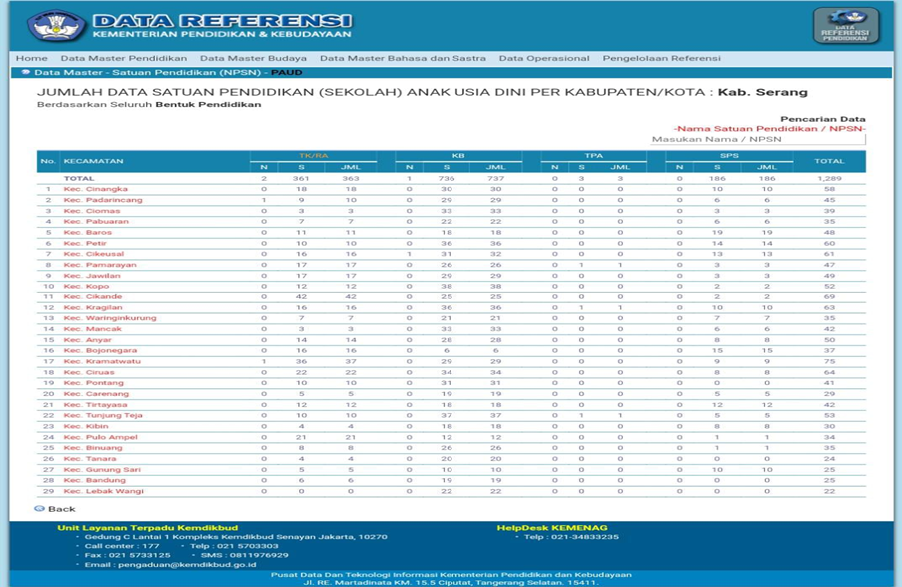
Source : Reference data Ministry of Education and Culture .

Table below _ this is results distributed interview _ through questionnaire to 1 26 respondent of 108 PAUD institutions in Serang Area .
Table 1. Interview results
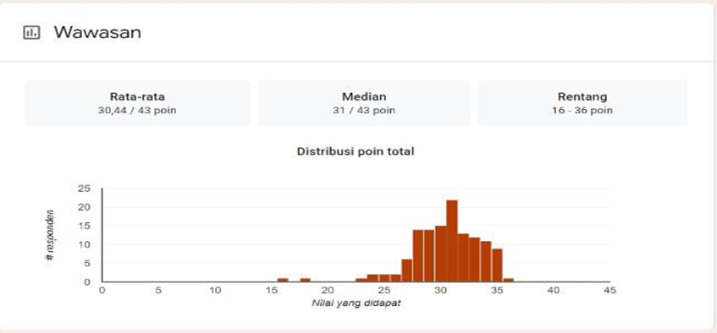
source : google form in the form of shared questions _ to respondents .
In t table 1 shows that the average value obtained from 126 respondents is 30.44. While the median value obtained from 126 respondents is 31 and the range of values obtained from 126 respondents is 16-36 points. From these results it can be concluded that the problem teaching PAUD teachers in the district attack experience enough problems _ significant especially in Thing system learning used _ for PAUD. This thing could seen based on the following diagram :

Table 2. Questionnaire Results
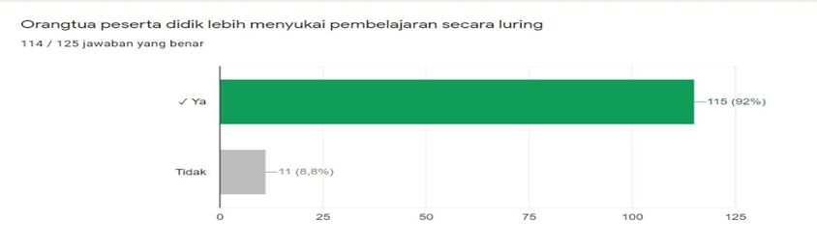

source : google form in the form of shared questions _ to respondents .

Based on The statement in table 2 shows that 115 respondents with a percentage of 92% answered 'yes' and 11 respondents with a percentage of 8.8% answered 'no'. It states that parents choose learning offline than learning online .

Table 3, Questionnaire Results
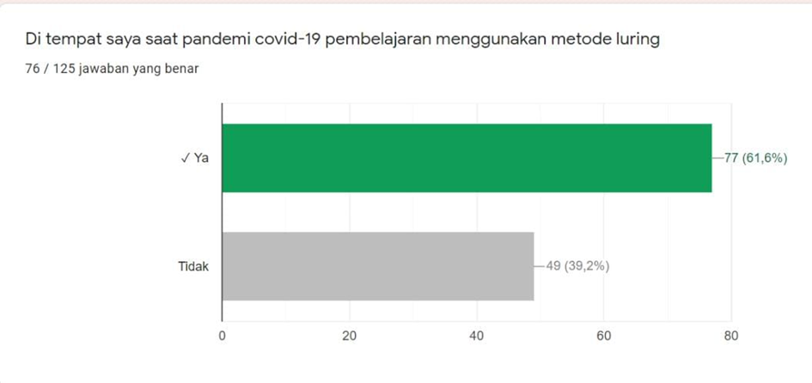
source : google form in the form of shared questions _ to respondents .

Based on table 3 diagram , it can be seen that that 77 respondents with a percentage of 61.6% answered 'yes' and 49 respondents with a percentage of 39.2% answered 'no'. This states that PAUD teachers and parents more like learning offline .

Table 4 Questionnaire Results 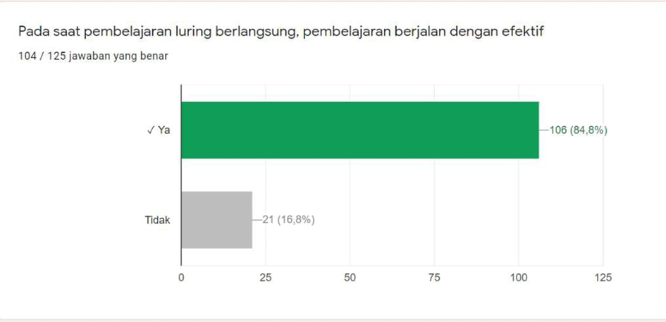
source : google form in the form of shared questions _ to respondents .

Based on results survey PAUD teachers and parents respondents , 106 respondents with a percentage of 84.8% answered 'yes' and 21 respondents with a percentage of 16.8% answered 'no'. It states that with offline learning learning process could walk effective .

Table 5 Questionnaire Results
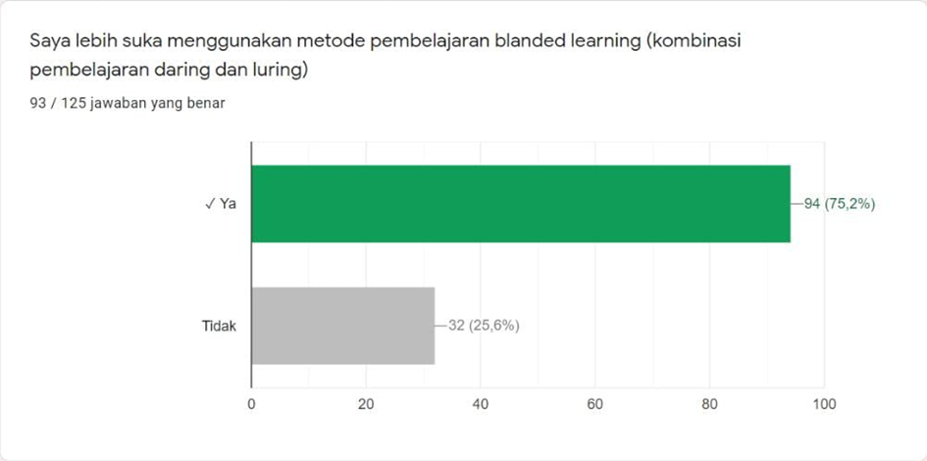
source : google form in the form of shared questions _ to respondents .

H result survey show 94 respondents answered 'yes' with a percentage of 75.2% and 32 respondents answered 'no' with a percentage of 25.6%. This indicates that most PAUD teachers are more choose for use blended learning .

Table 6, Questionnaire Results
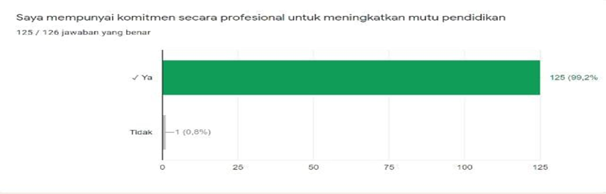
source : google form in the form of shared questions _ to respondents .

Based on Table 6 who answered 'yes' were 125 respondents with a percentage of 99.2% and answered 'no' 1 respondent with a percentage of 0.8%. It states that PAUD teachers have a professional commitment to improving the quality of education.

Table 7, Questionnaire Results
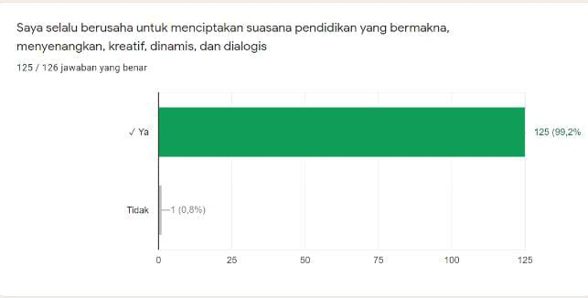
source : google form in the form of shared questions _ to respondents .

The diagram shows that 125 respondents answered 'yes' with a percentage of 99.2% and 1 respondent answered 'no' with a percentage of 0.8%. This states that PAUD teachers always attempted to create atmosphere education that is meaningful, fun , creative, dynamic, and dialogical.

Table 8, Results Questionnaire
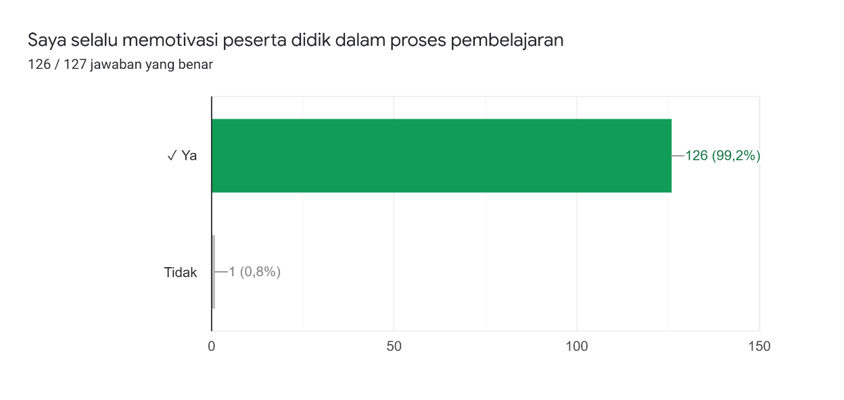
source : google form in the form of shared questions _ to respondents .

The diagram above shows that 125 respondents answered 'yes' with a percentage of 99.2% and 1 respondent answered 'no' with a percentage of 0.8%. This means that PAUD teachers always motivate students in the learning process.

DISCUSSION
From the results of our research on PAUD teachers in Serang District, most PAUD teachers said that most parents choose learning offline than learning online . Remember online learning is very difficult for part big parents , obstacles _ other including the lack of parental skills in IT , no _ own cell phone , and connection or network that can influence them . This thing in accordance with results research conducted by (Amalina , 2020) which states that learning online is very difficult done , especially learning that requires time and also the process of understanding child . This is also confirmed by (Dini, 2021) that about problem learning online , child difficult understand learning with good , lack facilities and infrastructure , problems other is no availability internet and network quota or bad connection _ so that could hinder study . Siti Rahmawati et al stated , other difficulties of students is no own necessary equipment , such as a laptop or computer computer .
The difficulties experienced by parents made several PAUD schools in Serang District carry out offline learning, learning was carried out offline or face to face using very strict health protocols. This turned out to make teachers and parents prefer offline learning. We got this statement from the results of distributing our questionnaire to PAUD teachers in Serang District.
In times of pandemic this , some method learning try and offer to parents , start _ from learning online , learning offline until blended learning ( combining learning online and offline ), and based on teacher's view , parents could accept method blended learning . H result study based on survey show more effective than online learning . It states that with learning offline learning process could walk effective . Besides that , researchers also see PAUD teacher competence and the factors that influence PAUD teachers in teaching during the COVID-19 pandemic .
Related _ the commitment to enhancement quality education in the Banten area , PAUD teachers said they were very enthusiastic for Upgrade quality education , thing this done through training and equalization education carried out by PAUD teachers in Serang District . This states that PAUD teachers always attempted to create atmosphere education that is meaningful, fun , creative, dynamic, and dialogical for students by always motivating students in the learning process.

CONCLUSION
Related PAUD teacher problems in teach During the COVID-19 pandemic that has been carried out survey to 126 PAUD teachers from 1 08 PAUD institutions in the district attack show same result and opinion , that is parents ' demands about system effective and optimal learning . parents _ want learning system offline or stare face , so that learning more effective and optimal . This is a challenge for PAUD teachers to continue to increase their knowledge professionally by participating in training and workshops organized by education units in Banten Province.
REFERENCE
Amalina, A. (2020). Early Childhood Mathematics Learning in the 2020 COVID-19 Pandemic. Journal of Obsession: Journal of Early Childhood Education , 5 (1), 538–548.
Anggraini, WD (2016). Analysis of Factors Affecting Learning Outcomes of Economics Subject Class XI IIS SMA (pp. 6–8).
Anugrahana, A. (2020). Obstacles, Solutions and Hopes : Online Learning During the Covid-19 Pandemic By Elementary School Teachers . 282–289.
Asmuni. (2020). The Problems of Online Learning during the Covid-19 Pandemic and Solutions for Solving It Journal of Paedagogy : Journal of Pedagogy : 7 (4), 281–288. https://doi.org/10.33394/jp.v7i4.2941
Darmadi, H. (2010). Basic Teaching Ability . Alphabet.
Dendy, S. (2008). Big Indonesian Dictionary Fourth Edition . grammar.
Dewi, WA (2020). The Impact of Covid-19 on the Implementation of Online Learning in Elementary Schools. Educational: Journal of Educational Sciences , 58 , 8.
Dini, JPAU (2021). The Problems of Early Childhood Online and Offline Learning for Teachers and Parents during the Covid 19 Pandemic. Obsession Journal: Journal of Early Childhood Education , 5 (2), 1825–1836.
Fadilla, AN, Relawati, AS, & Ratnaningsih, N. (2021). PROBLEMS OF ONLINE MATHEMATICS LEARNING IN THE TIME OF THE COVID-19 PANDEMIC . 01 (02), 48–60.
Harahap, SA, Dimyati, D., & Purwanta, E. (2021). The Problems of Early Childhood Online and Offline Learning for Teachers and Parents during the Covid 19 Pandemic. Obsession Journal : Journal of Early Childhood Education , 5 (2), 1825–1836. https://doi.org/10.31004/obsesi.v5i2.1013
Hilna Putria, LH (2020). Online Learning Process (DARING) During the COVID-19 Pandemic for Elementary School Teachers. Basicedu , 63 .
Michalopoulos, C., Faucetta, K., Hill, CJ, & ... (2019). Impact on family outcomes of evidence-based early childhood home visits: Outcomes of evaluation of maternal and infant home visiting programs. In … , and Evaluation of … . mathematica.org. https://www.mathematica.org/-/media/publications/pdfs/earlychildhood/2019/mihope_impact_r eport_final_508.pdf
muhaimin. (2012). Teaching and Learning Strategy . CitraMedia.
Mulyono. (2011). Learning Strategies Towards Effective Learning in the Global Century . UIN Maliki Press.
Nuryati, M., H., T., R., S., Imroatun, N., & D. (nd). Role Playing Method in Increasing Early Childhood Achievement Motivation During the Learning From Home Period (Vol. 6, Issue 2, pp. 139–148).
Pohan, AE (2020). The Concept of Online Learning Based on a Scientific Approach . CV. Sarnu Lucky.
Riyanda, AR, Herlina, K., & Wicaksono, BA (2020). Evaluation of the Implementation of the Online Learning System of the Faculty of Teacher Training and Education, University of Lampung. Journal of IKRA-ITH Humanities , 4 (1), 66–71. https://journals.upi-yai.ac.id/index.php/ikraith-humaniora/article/view/669
Saleh, AM (2020). Problems of education policy in the midst of a pandemic and considerations of the learning process in Indonesia .
Suhardan, D. (2014). Professional Supervision: Services in improving the Quality of Learning in the Era of Regional Autonomy . Alphabet.
Talango, SR, Nuryati, N., & Muthmainnah, M. (2021). Analysis of Children's Scientific Literacy Skills Related to Covid-19 Through the Story Telling Method at RA An-Najmush Saghir, Gorontalo. EduPsyCouns: Journal of Education, Psychology and Counseling , 3 (1), 268–276.
Wijayanti, F. (2017). PAI Teacher Problems in PAI Teaching and Learning Process .

