
Volume x Issue x (xxxx) Pages x-xx
Jurnal Obsesi : Jurnal Pendidikan Anak Usia Dini
ISSN: 2549-8959 (Online) 2356-1327 (Print)

Bibliometric Analysis: Parenting Program During the Worldwide Covid-19 Pandemic

Evi Selva Nirwana¹ Irfan Fauzi Rachmat²
PIAUD, UIN Fatmawati Sukarno Bengkulu ⁽¹⁾ PAUD, Universitas Muhammadiyah Cirebon⁽²⁾

DOI:

Abstract
This study aimed to obtain the right parenting program when the Covid-19 pandemic through bibliometric analysis. Bibliometric analysis was conducted to overview parenting model research during the Covid-19 outbreak. The study of parenting programs during a pandemic is deemed necessary for mapping to determine what research themes have been studied in the study of parenting programs, research trends, authors, productive affiliations, and research opportunities for parenting models that can be carried out in Indonesia. This research data is metadata extracted from the Scopus database with the source "Parenting during Covid-19" using the VOS viewer application. All this information is exported to CSV format using M. Excel 2021 software for data analysis. The number of document metadata that has been collected is 200 articles. The analysis results show that the development of parenting programs published in the Scopus journal has 200 publications. There are publications on Scopus data in 2020 as many as 82 articles, and the most are in 2021, which is 118 articles. Most publications for the parenting field are in the journal Frontiers Psychology and the International Journal of Environmental Research and Public Health, with nine pieces. Meanwhile, the most productive authors, who published more than 1 article related to parenting during covid-19 indexed by the Scopus index, were nine authors, namely A.B. Mahmoud; A.E. Goldberg; B.S. Russell; E.M. Westrupp; M. Morelli; Q.Wu; S. Kelly; S.J. Lee; Y. Xu. Research related to parenting programs during the COVID-19 pandemic has been widely researched and easily accessed. By involving various disciplines, parenting is one of the good topics to be explored by early childhood education scientists.
Kata Kunci: bibliometric analysis, parenting, covid-19 pandemic.

Abstrak
Tujuan penelitian ini adalah untuk mendapatkan program parenting yang tepat saat pandemi Covid-19 melalui cara analisis bibliometric. Analisis bibliometric dilakukan untuk mendapatkan gambaran umum mengenai riset-riset model parenting saat terjadi wabah Covid-19. Kajian program parenting saat pandemic dirasa perlu ada suatu pemetaan, untuk menentukan tema riset apa saja yang telah diteliti pada kajian program parenting, tren risetnya, penulis, afiliasi produktif, serta peluang riset model parenting yang dapat dilakukan di Indonesia. Data riset ini merupakan metadata yang di ekstrak dari basis data scopus dengan sumber “Parenting during Covid-19” dengan menggunakan aplikasi VOSviewer. Seluruh informasi ini diekspor ke format CSV untuk keperluan analisis data dengan menggunakan software M. Excell 2021. Jumlah metadata dokumen yang berhasil di kumpulkan adalah sebanyak 200 artikel. Hasil analisis menunjukkan bahwa perkembangan program parenting yang di publikasi pada jurnal scopus memiliki 200 publikasi. Dimana publikasi pada data scopus terjadi mulai tahun 2020 sebanyak 82 artikel, dan terbanyak adalah di tahun 2021, yaitu 118 artikel. Publikasi terbanyak untuk bidang parenting terdapat pada jurnal Frontiers Psychology dan International Journal of Environmental Research and Public Health sebanyak 9 artikel. Sedangkan penulis ter produktif, yang menghasilkan publikasi artikel lebih dari 1 terkait parenting during covid-19 yang ter indeks scopus adalah terdapat 9 penulis, yaitu A.B. Mahmoud; A.E. Goldberg; B.S. Russell; E.M. Westrupp; M. Morelli; Q. Wu; S. Kelly; S.J. Lee; Y. Xu. Riset terkait program parenting dimasa pandemic covid-19 telah banyak diteliti, dan dapat diakses dengan mudah. Dengan melibatkan berbagai disiplin ilmu, topik parenting salah satu topik yang menjanjikan untuk lebih diteliti oleh para ilmuwan PAUD.
Keywords: content; formatting; article.

Copyright (c) 2022 Irfan Fauzi Rachmat.
Corresponding author :
Email Address : selvanirwana@gmail.com (Bengkulu, Indonesia, Indonesia)
Received …………, Accepted ……….., Published ……………

introduction
The covid-19 pandemic is happening all over the world. Recent developments have shown a relatively significant downward graph. The data shows that the downward trend in Covid has been sloping. Especially in Indonesia, the latest data taken from the website https://covid19.go.id/ indicates that there are 4 million people exposed to COVID-19 in Indonesia, and the last update was recorded until November 22, 2021, who died from Covid was 143,000.
The occurrence of Covid-19 has certainly changed various kinds of habits in society. Habits of behaving in everyday life, or maybe habits in interacting in a social environment. The pattern of interactions between humans has changed; exchanges usually done face-to-face have turned online. Online meetings in cyberspace have become a new habit in their activities. They started from office activities and schools to economic activities moving into the digital world (Forbes et al., 2021).
Family life habits have changed in many aspects. That occurs in a minor environment. The most miniature environment is the family environment. The family is one of the minor units in an environmental system. They have an organizational structure such as father, mother, children, grandparents, or others who are gathered and live in one place together, interdependent. Families can be divided into small families, large families.
Parenting programs focus on behavioral changes that occur in parents. Parenting is the way, style, or method of parents in treating, educating, guiding, and disciplining children in the maturation process through an interactive process that is influenced by many factors, such as culture, religion, habits, and beliefs so that children can grow and develop according to knowledge. , moral values, and standards of behavior that apply in the social environment and society.
Of course, changes in this family environment do not only occur in Indonesia. Almost all countries in the world are experiencing the Covid pandemic. Families in several developed and developing countries have certainly changed the parenting pattern in their families. From those who initially worked in the office to work at home, studying at school became learning from home. Parents who are usually less involved in children's learning activities become active and obliged to provide learning for children and others. So this pattern of change, whether consciously or not, becomes a habit that most families enjoy and enjoy, but on the other hand, many families also feel pressured or uncomfortable.
This lack of comfort and pressure can arise because parents are not ready to carry out activities that should be done at the office and then have to move home. Parents who are busy in the office have to move their work to home. Coupled with the involvement of children studying at home or at the same time caring for children, parents feel disturbed at the end (Brown et al., 2020). Worried because they think the workload is different because they are done at home, and the intervention from children can damage concentration and focus at work.
This phenomenon indeed occurs in several cities around the world. Millennial parents are busy with their work and only take the time to play with their children on weekends, where their children are entrusted with daily care by maids or baby sisters. This problem is enough to make it difficult for millennial parents. Young parents, who have to divide their time to raise children and focus on developing their careers, will experience their challenges due to the COVID-19 pandemic (Cluver et al., 2020). This phenomenon and pattern of parenting changes will be examined in this research.
This research aims to determine the direction of the mapping or road map, or research trends related to a particular topic. The bibliometric analysis technique was taken to show issues to look for and how these topics could relate to one another. Not only that, but the bibliometric analysis will also show how a case develops over time (Eck & Waltman, 2010).
Thus, this research aims to focus on the study of parenting programs. The study of parenting programs during the covid-19 pandemic worldwide is fascinating to discuss. Look for research trends, authors or top authors who discuss parenting-related programs, and collaborators who study the same topic. So it is hoped that a density or overlay can be found which shows the grouping or cluster of relationships between journals, co-authoring, names of researchers, and keywords that appear in the bibliometric analysis.

METHOD
This study uses bibliometric analysis. The term "bibliometric analysis" can be defined as a statistical evaluation of a scientific publication, whether in the form of a journal, book, or another scientific article (Eck & Waltman, 2010). Not only that but "bibliometric analysis" is also a way to measure and evaluate the influence of a publication, scientific research, or measurement of the quality of an institution in the scientific community.
Quite a several researchers have used this method to explore the influence of a particular scientific field. Usually, this method is used by librarians and researchers in all areas. We can review a current research theme and potential future themes that will trend through bibliometric analysis. Not only will the possible future research themes look like, but also tracking a research group or community in a particular paper that impacts a specific field.
The flow of this research is the first, collecting all the articles that appear after searching for them in the publish and perish application with the source keyword "parenting during covid-19". The number of reports collected is as many as 200 articles. Researchers deliberately limit the range of years between 2019 to 2021 because there was an outbreak or a reasonably significant spread of the covid virus in those early years. Then, the selected articles are articles taken from the Scopus database. It is done because Scopus is a large company that provides the most extensive abstracts and citation databases from peer-reviewed literature: scientific journals, books, and conference proceedings. So that the reputation of Scopus is no longer in doubt related to the reliability of scientific sources and literature that will be cited, the researchers decided that only articles with a Scopus index would be investigated further using bibliometric analysis.
Then, after collecting articles using the publish and perish application, the second is downloading the data source by first changing the file type to CSV and also to excel type. It is done to make it easier to filter each article category, whether the category number h index, ranking, author, article title, year of publication, journal in which it is published, or type of article. After that, the data is converted into RIS data to be analyzed using the VOS Viewer application.
VOS Viewer is a software or tool for constructing and visualizing bibliometric relationships from a journal, article, book, or another type of publication. The RIS data type is then used to answer the objectives of this study. So that we get a conclusion related to the research trend of "parenting during the covid-19 worldwide pandemic".

RESULT AND DISCUSSION
After conducting studies and research carried out following the above method stages, a research result was obtained, which can be explained as follows.
The number of articles that have been collected is as many as 200 articles. They all of which are indexed by Scopus. Of the 200 reports, it shows the number of the most prolific writers, and also, the titles of the articles are pretty interesting. The number of articles can be seen in the following excel table link: Collection of 200 Parenting Articles During Covid on Scopus
Of the 200 articles, the majority is only one author in articles related to parenting during covid-19. 13 authors compiled Scopus indexed articles of two articles each. The authors are (Alhuzimi, 2021; Babore et al., 2021; Chen et al., 2020; Goldberg et al., 2021; Kelly et al., 2020; Lee et al., 2021; Mahmoud et al., 2020, 2021; Morelli et al., 2020; BS Russell et al., 2020; Beth S Russell et al., 2021; EM Westrupp et al., 2021; Elizabeth M Westrupp et al., 2020; Ye et al., 2021). Of the 13 authors publish their articles with various themes. Meanwhile, other writers consistently write ideas about the relationship between parenting programs during covid-19.
The range of years used in this study is from 2019 to 2021. The data collection results show that the highest number of Scopus indexed publications occurred in 2021, namely 118 articles. Furthermore, the rest, namely 82 articles published in 2020.
While related to publishers or publishers, 133 publishers or publishers of journal names are collected. The publishers who produce the most articles related to parenting during covid-19 are found in the journal Frontiers in Psychology and the International Journal of Environmental Research and Public Health, each with nine pieces. Meanwhile, the second-largest journal is Family Process, with six articles published, and the third is the Journal of Family Violence and Research in Developmental Disabilities, each with five articles.
The metadata of this article was downloaded on November 23, 2021. The downloaded bibliometric data includes all of them, whether in articles, books, editorials, or others. Regarding the types of publication articles, there are 162 articles: book 1, book chapter 1, editorial 2, letter 8, note 10, and review 16. The researcher takes not only the type of article, but it adds variety to the findings and impacts or strengthens each other a topic under study. To determine the distribution of research titles and abstracts, the researcher attaches the following link as an excel data file for the 200 publications.
Meanwhile, the most cited publication titles are from L. Cluver, with the title Parenting in Covid-19 published by The Lancet in 2020. The type of this article is in the form of a letter. While the other top five authors can be seen in the following table:
Table 1. List of 10 publications articles showing the most prolific authors, publishers, and most cited publication titles.
No | Author | Cited | Year
 | (Cluver et al., 2020) | 263 | 2020
 | (Brown et al., 2020) | 189 | 2020
 | (Griffith, 2020) | 113 | 2020
 | (Ghosh et al., 2020) | 112 | 2020
 | (B. S. Russell et al., 2020) | 95 | 2020
 | (Badawy & Radovic, 2020) | 63 | 2020
 | (Chung et al., 2020) | 57 | 2020
 | (Marchetti et al., 2020) | 54 | 2020
 | F. Staniscuaski | 53 | 2020
 | (Yoshikawa et al., 2020) | 52 | 2020

Bibliometric Network, and Parenting Program Research Trends During Covid.
The next step is to analyze the previously described data into the bibliometric analysis. This bibliometric analysis creates a network, overlay, and density visualizations using the Vos Viewer application. It is done to find out the biometric network between the articles from the downloaded metadata.
The bibliometric networks have terms such as nodes and edges. The Nodes are visualizations such as circles indicating related researchers, publications, journals, or keywords. It is connected to the edge. Edge is a line relationship that means a relationship between each node. It not only shows the connection between nodes, but the edge also shows the level of the strong relationship. The closer the distance between the nodes, the higher the level of relationship between the nodes.
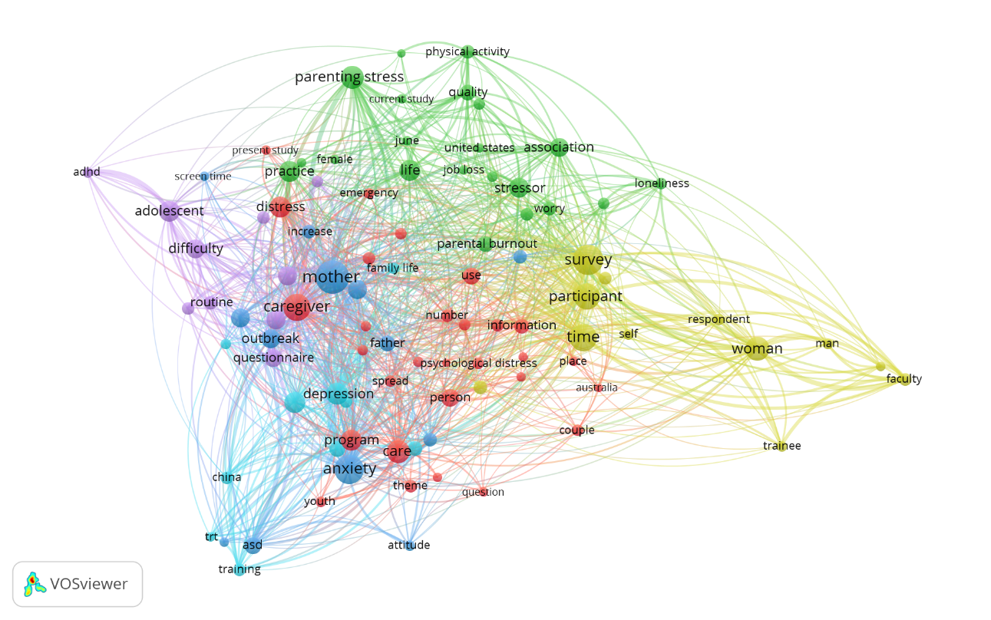
Figure 1. Visualization of Nodes and Edges in Article Publication with the Theme: Pandemic During Covid 19.
From the picture, it can be seen the results of mapping and also clustering. Mapping is done to obtain a detailed picture of the bibliometric network (Waltman et al., 2010). Clustering is used to gain insightful or insight for researchers or readers so that they can show bibliometric grouping.
The picture above shows that the circle shows keywords or terms that often appear in article titles or abstracts. The size of the process indicates the relevance of each article. The bigger each rotation, the greater the relevance to that keyword or term. Examples are mother, caregiver, anxiety, parenting stress, care. These keywords often appear in the title or abstract and relate to each article.
The results of the 200 articles collected have shown some six clusters. The six clusters can be seen from the grouping of the same color. The first cluster consists of 29 red items that are in a more central position, including terms or keywords such as: Addition, article, australia, burden, care, caregiver, couple, depressive symptom, distress, emergency, face, information, isolation , number, order, paper, patient, person, place, present study, program, psychological distress. Then the second cluster consists of 21 dark green items in the top position, consisting of Association, child maltreatment, current study, female, higher level, home order, job loss, June, lack, life, loneliness, mage, parental burnout. Important stress, physical activity, practice, quality, social isolation, stressor, united states, worry. Next, the third cluster consists of a collection of nodes that are dark blue, consisting of 13 items, such as: the terms Anxiety, ASD, attitude, autism spectrum disorders, father, gender, increase, mother, outbreak, parental stress, scale, screen time, social support.
Next, the fourth cluster consists of 12 light green items: Employment, faculty, importance, man, participant, respondent, self, survey, time, trainee, woman, young child. The fifth purple cluster consists of 10 items on the far left: Adhd, adolescent, difficulty, mothers, quarantine, questionnaire, relation, routine, school, student. Then the last one is the sixth cluster, which is light blue and consists of 10 items, namely, Baseline, China, context, depression, evidence of family life, intervention, training, trt, week.

Table 2. Clustering on Vos Viewer Visualization Sorted by Alphabet (Alphabetical).
Cluster | Keyword
Cluster 1 (29 items) red color | Addition, article, australia, burden, care, caregiver, couple, depressive symptom, distress, emergency, face, information, isolation, number, order, paper, patient, person, place, present study, program, psychological distress
Cluster 2 (21 items) dark green | Association, child maltreatment, current study, female, higher level, home order, job loss, June, lack, life, loneliness, mage, parental burnout, paenting stress, physical activity, practice, quality, social isolation, stressor, united states, worry
Cluster 3 (13 items) dark blue | Anxiety, asd, attitude, autism spectrum disorders, father, gender, increase, mother, outbreak, parental stress, scale, screen time, social support.
Cluster 4 (12 items) light green color | Employment, faculty, importance, man, participant, respondent, self, survey, time, trainee, woman, young child.
Cluster 5 (10 items ) purple color | Adhd, adolescent, difficulty, mothers, quarantine, questionnaire, relation, routine, school, student.
Cluster 6 (10 items) light blue | Baseline, china, context, depression, evidence family life, intervention, training, trt, week.

The cluster above shows the relationship between each of its groups. The next step is mapping research trends based on the year of publication. This section will be shown on the overlay menu in the Vos viewer application. This overlay is used to determine research trends related to parenting programs during the covid pandemic worldwide. Even though the covid hit started in late 2019 until 2021, the overlay data showed that researchers started publishing it from March 2020 to August 2020.
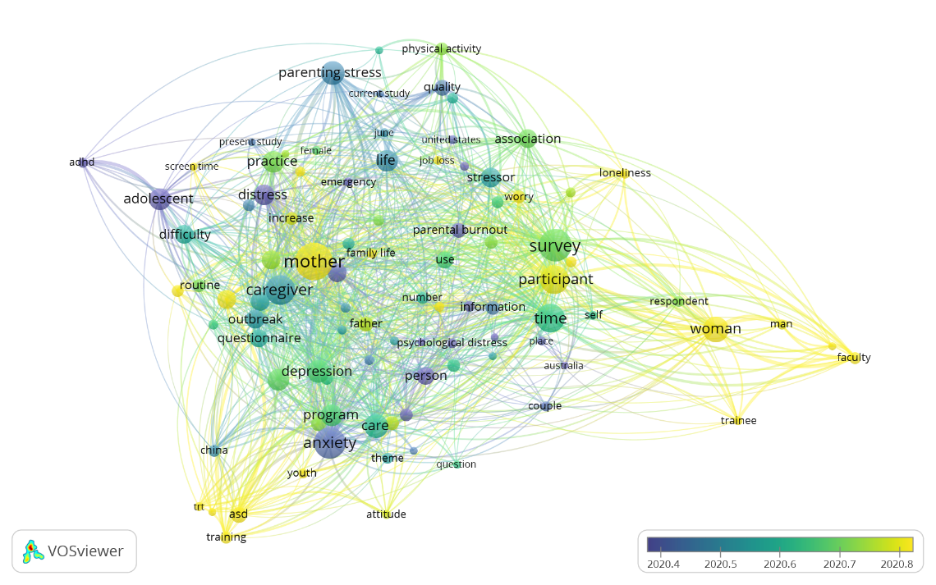
Figure 2. Overlay visualization to see the trend of the research year.
The overlay visualization shown in the image above indicates circles or nodes as keywords. These nodes have various color nodes that indicate the year the article was published. Because this covid pandemic occurs between late 2019 and 2021, the time distance shown is in the same year, only showing the difference in months. That is only six months, between March to August 2020.
Visualization Vos viewer also displays primary colors such as RGB (red, green, and blue). Figure 3 shows that several nodes are close to each other. The most yellow color represents the saturation level of each node. In other words, the topics that have been studied the most during the COVID-19 pandemic related to parenting are the terms anxiety, mother, caregiver, parenting stress. Then other terms that have another level of yellow color are survey, participant, time. It means that these topics have been thoroughly researched

.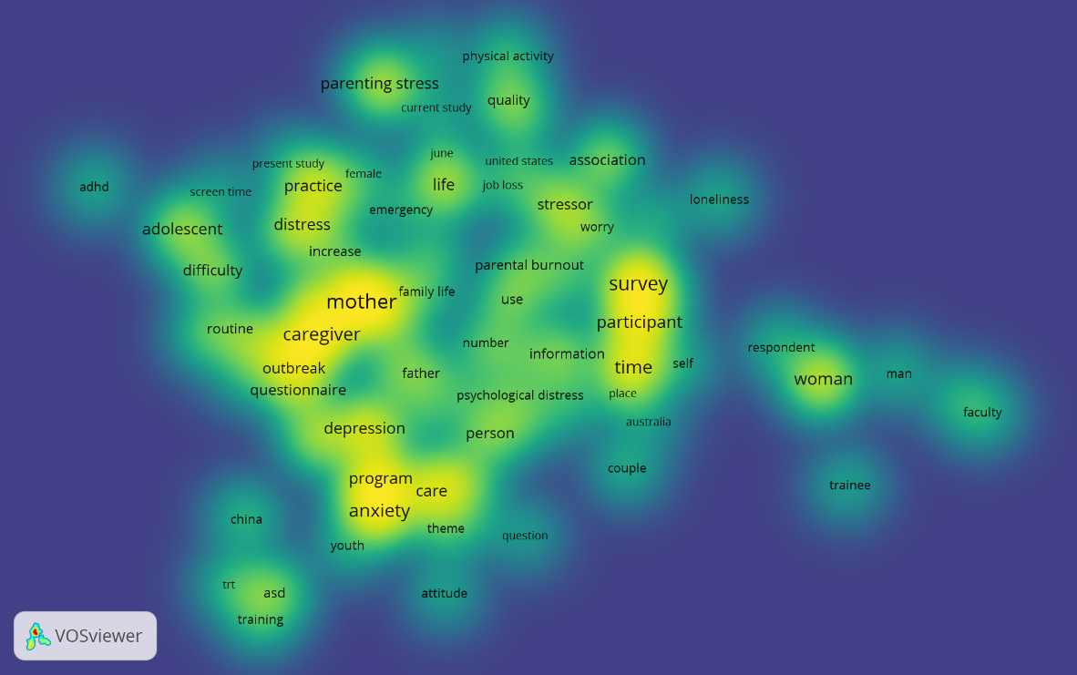
Figure 3. Visualization of Nodes and Edges in Article Publication with the Theme: Pandemic During Covid 19.
Meanwhile, another topic related to parenting during covid 19 is those with a dark yellow color. That can be seen from Figure 3, such as the terms adhd, loneliness, attitude, screen time, job loss, and psychological distress to see the trends and trends of subsequent research by taking the term.

CONCLUSIONS
The theme of parenting during the covid pandemic is an exciting theme to be discussed in reputable international journals. It can be seen that reputed international journals that Scopus have indexed have published various articles about various parenting changes that have changed due to Covid-19. Differences in parenting habits, work habits, and habits of approach to educating children have changed.
From these 200 articles, we have found one exciting research development opportunity to be discussed or researched. The theme of research on parenting is a potential topic to be published in several other reputable international journals. Encourage early childhood researchers to conduct the best research in the field of early childhood development. The hope is that the many studies that have been carried out related to parenting will provide an overview and improve the quality of care for early childhood, especially parenting after the COVID-19 pandemic.

REFERENCES
Alhuzimi, T. (2021). Stress and emotional wellbeing of parents due to change in routine for children with Autism Spectrum Disorder (ASD) at home during COVID-19 pandemic in Saudi Arabia. Research in Developmental Disabilities, 108(August 2020), 103822. https://doi.org/10.1016/j.ridd.2020.103822
Babore, A., Trumello, C., Lombardi, L., Candelori, C., Chirumbolo, A., Cattelino, E., Baiocco, R., Bramanti, S. M., Viceconti, M. L., Pignataro, S., & Morelli, M. (2021). Mothers' and Children's Mental Health During the COVID-19 Pandemic Lockdown: The Mediating Role of Parenting Stress. Child Psychiatry and Human Development. https://doi.org/10.1007/s10578-021-01230-6
Badawy, S. M., & Radovic, A. (2020). Digital approaches to remote pediatric health care delivery during the COVID-19 pandemic: Existing evidence and a call for further research. JMIR Pediatrics and Parenting, 3(1). https://doi.org/10.2196/20049
Brown, S. M., Doom, J. R., Lechuga-Peña, S., Watamura, S. E., & Koppels, T. (2020). Stress and parenting during the global COVID-19 pandemic. Child Abuse and Neglect, 110(June). https://doi.org/10.1016/j.chiabu.2020.104699
Chen, S., Cheng, Z., & Wu, J. (2020). Risk factors for adolescents' mental health during the COVID-19 pandemic: A comparison between Wuhan and other urban areas in China. Globalization and Health, 16(1), 1–11. https://doi.org/10.1186/s12992-020-00627-7
Chung, G., Lanier, P., & Wong, P. Y. J. (2020). Mediating Effects of Parental Stress on Harsh Parenting and Parent-Child Relationship during Coronavirus (COVID-19) Pandemic in Singapore. Journal of Family Violence, 1–12.
Cluver, L., Lachman, J. M., Sherr, L., Wessels, I., Krug, E., Rakotomalala, S., Blight, S., Hillis, S., Bachman, G., Green, O., Butchart, A., Tomlinson, M., Ward, C. L., Doubt, J., & McDonald, K. (2020). Parenting in a time of COVID-19. The Lancet, 395(10231), e64. https://doi.org/10.1016/S0140-6736(20)30736-4
Eck, N. J. van, & Waltman, L. (2010). A Comparison of TwoTechniques for Bibliometric Mapping: Multidimensional Scaling and VOS. JOURNAL OF THE AMERICAN SOCIETY FOR INFORMATION SCIENCE AND TECHNOLOGY, 61(12), 2405–2416. https://doi.org/10.1002/asi
Forbes, L. K., Lamar, M. R., Speciale, M., & Donovan, C. (2021). Mothers' and fathers' parenting attitudes during COVID-19. Current Psychology. https://doi.org/10.1007/s12144-021-01605-x
Ghosh, R., Dubey, M. J., Chatterjee, S., & Dubey, S. (2020). Impact of COVID-19 on children: Special focus on the psychosocial aspect. Minerva Pediatrica, 72(3), 226–235. https://doi.org/10.23736/S0026-4946.20.05887-9
Goldberg, A. E., McCormick, N., & Virginia, H. (2021). Parenting in a Pandemic: Work–Family Arrangements, Well-Being, and Intimate Relationships Among Adoptive Parents. Family Relations, 70(1), 7–25. https://doi.org/10.1111/fare.12528
Griffith, A. K. (2020). Parental Burnout and Child Maltreatment During the COVID-19 Pandemic. In Journal of Family Violence. Springer. https://doi.org/10.1007/s10896-020-00172-2
Kelly, S., Jeremie-Brink, G., Chambers, A. L., & Smith-Bynum, M. A. (2020). The Black Lives Matter Movement: A Call to Action for Couple and Family Therapists. Family Process, 59(4), 1374–1388. https://doi.org/10.1111/famp.12614
Lee, S. J., Ward, K. P., Lee, J. Y., & Rodriguez, C. M. (2021). Parental Social Isolation and Child Maltreatment Risk during the COVID-19 Pandemic. Journal of Family Violence, 2020. https://doi.org/10.1007/s10896-020-00244-3
Mahmoud, A. B., Hack-Polay, D., Fuxman, L., Naquiallah, D., & Grigoriou, N. (2020). Trick or treat? - When children with childhood food allergies lead parents into unhealthy food choices. BMC Public Health, 20(1). https://doi.org/10.1186/s12889-020-09556-x
Mahmoud, A. B., Hack-Polay, D., Fuxman, L., & Nicoletti, M. (2021). The Janus-faced effects of COVID-19 perceptions on family healthy eating behavior: Parent's negative experience as a mediator and gender as a moderator. Scandinavian Journal of Psychology, 62(4), 586–595. https://doi.org/10.1111/sjop.12742
Marchetti, D., Fontanesi, L., Mazza, C., Di Giandomenico, S., Roma, P., & Verrocchio, M. C. (2020). Parenting-related exhaustion during the italian COVID-19 lockdown. Journal of Pediatric Psychology, 45(10), 1114–1123. https://doi.org/10.1093/jpepsy/jsaa093
Morelli, M., Cattelino, E., Baiocco, R., Trumello, C., Babore, A., Candelori, C., & Chirumbolo, A. (2020). Parents and Children During the COVID-19 Lockdown: The Influence of Parenting Distress and Parenting Self-Efficacy on Children's Emotional Well-Being. Frontiers in Psychology, 11(October), 1–10. https://doi.org/10.3389/fpsyg.2020.584645
Russell, B. S., Hutchison, M., Tambling, R., Tomkunas, A. J., & Horton, A. L. (2020). Initial Challenges of Caregiving During COVID-19: Caregiver Burden, Mental Health, and the Parent–Child Relationship. Child Psychiatry and Human Development, 51(5), 671–682. https://doi.org/10.1007/s10578-020-01037-x
Russell, Beth S, Fendrich, M., Hutchison, M., Fox, L. F., & Park, C. L. (2021). Short ‐ term impacts of COVID ‐ 19 on family caregivers : Emotion regulation , coping , and mental health. J Clin Psychol, March. https://doi.org/10.1002/jclp.23228
Westrupp, E M, Bennett, C., Berkowitz, T., Youssef, G. J., Toumbourou, J. W., Tucker, R., Andrews, F. J., Evans, S., Teague, S. J., Karantzas, G. C., Melvin, G. M., Olsson, C., Macdonald, J. A., Greenwood, C. J., Mikocka-Walus, A., Hutchinson, D., Fuller-Tyszkiewicz, M., Stokes, M. A., Olive, L., … Sciberras, E. (2021). Child, parent, and family mental health and functioning in Australia during COVID-19: comparison to pre-pandemic data. European Child and Adolescent Psychiatry, 0123456789. https://doi.org/10.1007/s00787-021-01861-z
Westrupp, Elizabeth M, Karantzas, G., Macdonald, J. A., Olive, L., Youssef, G., Greenwood, C. J., Sciberras, E., Fuller-Tyszkiewicz, M., Evans, S., Mikocka-Walus, A., Ling, M., Cummins, R., Hutchinson, D., Melvin, G., Fernando, J. W., Teague, S., Wood, A. G., Toumbourou, J. W., Berkowitz, T., … Olsson, C. A. (2020). Study Protocol for the COVID-19 Pandemic Adjustment Survey (CPAS): A Longitudinal Study of Australian Parents of a Child 0–18 Years. Frontiers in Psychiatry, 11(August), 1–11. https://doi.org/10.3389/fpsyt.2020.555750
Ye, Y., Wang, C., Zhu, Q., He, M., Havawala, M., Bai, X., & Wang, T. (2021). Parenting and Teacher–Student Relationship as Protective Factors for Chinese Adolescent Adjustment During COVID-19. School Psychology Review, 0(0), 1–19. https://doi.org/10.1080/2372966X.2021.1897478
Yoshikawa, H., Wuermli, A. J., Britto, P. R., Dreyer, B., Leckman, J. F., Lye, S. J., Ponguta, L. A., Richter, L. M., & Stein, A. (2020). Effects of the Global Coronavirus Disease-2019 Pandemic on Early Childhood Development: Short- and Long-Term Risks and Mitigating Program and Policy Actions. Journal of Pediatrics, 223(1), 188–193. https://doi.org/10.1016/j.jpeds.2020.05.020

